Name of Centre:  Lambeth College |  |  | Learner achievement (please circle) NB: All learner achievement is provisional until confirmed at the AVA Awards Board
 |  |  | Level Achieved: |  | L2 | 3 credits
 |  |  | Final Grade Achieved  (Level 2 units only) |  | P
 |  |  | Resubmission? |  | Y | N

L2 Dip. In Skills for Further study in Health and Human Sciences

Unit title(s): Infection and Immunity |  | Unit code(s): PA1/2/LQ/031
Learner:  Group: _____ |  | Tutor/Assessor: Washington Ogwang
Description of Assignment:
Assignment 1: Worksheet of questions and practical covering assessment criteria 1.1 , 1.2, 2.1, 2.1, 3.1,3.2, 4.1,4.2, 5.1 and 5.2

All components need to be submitted in order to pass the unit.
Date set: WB 6/05/2019 |  |  |  | Date for final: WB 3/06/2019  submission:
Extension date  (if agreed): | Signed by Tutor/Assessor to agree extension: |  |  | Date  submitted:
Learner declaration:
- The explanations and evaluations in this work have been developed and written by me.
- I have not submitted material copied from the Internet, text books or other sources in place of my thinking and writing.
- When I have referred to the work of others, I have done so to discuss, comment on, or argue their ideas.
- I have kept quotation and paraphrasing to an absolute minimum and only to support the points I have made.
- I understand that referencing the names of authors whose ideas I have used without including my interpretation of those ideas, does not meet the assessment criteria and cannot attract the Pass, Merit, or Distinction grades.
- I have not copied the work of my peers.

Learner comments: (please use this space to comment on any aspect of the assignment when handing in your work)
Signature: |  |  | Date:

TO THE LEARNER: Please attach this assignment brief to any written work you are handing in for an assessment, or submit the brief as instructed. YOUR WORK CANNOT BE ASSESSED UNLESS YOU HAVE SIGNED AND SUBMITTED THIS FORM

LEARNING OUTCOMES | ASSESSMENT CRITERIA
The learner will: | The learner can:
1. Understand the main types of pathogens and their mode of transmission | - Identify the main types of pathogen.  Viruses  Bacteria  Fungi  parasites  1.2 Describe the mode of transport of the main types of pathogens  Parasites. They are transmitted through contaminated soil, water, food, and blood, as well as through sexual contact.  Viruses. They can be transported from one person to another through contaminated blood and other body fluid.  Fungi. They are transmitted in the body through tiny cracks in the skin and also by walking bare feet. This happens when a person walks barefoot on warm, moist areas, like a locker room or public pool.  Bacteria. They can be transmitted through body fluids, such as blood, saliva, and semen can contain the infecting organisms and transmission of such fluids, for example by injection or sexual contact.
2. Understand the nonspecific defenses of the body | 2.1. Describe nonspecific defenses of the body  With nonspecific defenses of the body, the protection is always the same, no matter what the invader may be. Examples of nonspecific defenses include physical barriers, protein defenses, cellular defenses, inflammation, and fever.
3. Understand the organization of the immune system and the immune response | 3.1. Describe the organisation of the immune system  The human immune system is well organized whereby it has sites of production like the bone marrow and the thymus as well as sections of differentiation and proliferation, which include lymph nodes and the spleen. The immune organization also occurs in the lung, gastrointestinal tract, skin, and adipose tissue.  3.2. Describe the immune response  The immune response is how the body identifies and defend itself against bacteria, viruses, and substances that are harmful in the body. The immune system identifies and destroys materials that contain antigens. Antigens are substances (usual proteins in nature) on the surface of cells, viruses, fungi, or bacteria.
4. Understand what is meant by acquired immunity | 4.1. Describe what is meant by acquired immunity.  Acquired immunity is the immunity acquired by infection, vaccination, or by the transfer of antibody and lymphocytes from an immune donor. Acquired protection is in contrast to innate immunity (natural immunity).  4.2. Describe how vaccines work  Vaccines are just like a training course for the immune system. They prepare the body to fight disease without exposing it to disease symptoms.  When foreign invaders like bacteria and viruses enter the body, immune cells called the lymphocytes to respond by producing antibodies, which are protein molecules. These antibodies fight the invader known as an antigen and protect against further infection.
5. Understand the role of antibiotics in treating an infection. | 5.1 Describe how antibiotic works  Antibiotics work by affecting things that bacterial cells have, but human cells do not have. For example, human cells do not have cell walls, while many types of bacteria have. For instance, the antibiotic penicillin works by keeping a bacterium from building a cell wall. Some antibiotics dissolve the membrane of just bacterial cells.  5.2Describe how antibiotics are used to treat infection.  First and foremost, it is better to know whether an infection is bacterial or viral, which helps to treat it effectively. When people overuse antibiotics or use them incorrectly, the bacteria become resistant to treatment. This means that the antibiotic becomes less effective against that type of bacterium, as the bacterium has been able to improve its defense mechanisms.

Title of Pre-Access OCNLR

Unit title(s): Diet and Nutrition |  |  |  |  |  |  |  | Unit code(s): PA1/2/LQ/073
Learner: |  |  |  |  |  |  |  | Tutor/Assessor: Washington Ogwang
Part A: Feedback on credit level
AC no |  | Credit achieved L2 |  | Location of evidence |  |  | Tutor/Assessor comments on assessment criteria  (you could also indicate on the work itself where each AC is met)
1.1 , 1.2 |  |  |  | Task 1a & b
2.1 |  |  |  | Task 2
3.1 ,3.2 |  |  |  | Task 3
4.1. 4.2 |  |  |  | Task 4a & b
5.1 & 5.2 |  |  |  | Task 5a & b
Level achieved |  |  |  | Tutor/Assessor’s signature: |  |  |  |  |  |  |  | Date:
Resubmission (if applicable) If any of the assessment criteria for this assignment have not been met at Level 2, a resubmission may be permitted. Resubmission must follow the QAA guidelines and be permitted only once.
Requirements for resubmission/new Task set:

Date Set: |  |  |  |  |  | Date due: |  |  |  |  | Date Submitted:
Feedback on resubmission:

Level achieved  after resubmission: |  |  |  |  | Tutor/Assessor’s signature: |  |  |  |  |  | Date:

Understand the main types of pathogens and their mode of transmission (criteria 1.1 & 1.2)

Task 1a. (1.1)

List the types of pathogens and state a disease caused by each of them. You might also like to refer to how the disease is controlled,
TYPE OF PATHOGEN | DISEASE | CONTROL
Viruses | Hepatitis C | Avoiding direct exposure to blood or blood products as well as sharing of personal care items.
Bacteria | Meningitis | Careful hand-washing helps prevent the spread of germs.  Maintain the immune system by getting enough rest, exercising regularly, and eating a healthy diet with plenty of fresh fruits, vegetables, and whole grains.
Fungi | Ringworm | Washing hands often help to avoid the spread of infection. Keep common or shared areas clean, especially in schools, child care centers, gyms, and locker rooms.  Avoiding putting on of thick clothes for long periods in warm, humid weather. Avoid excessive sweating.
Parasites | Malaria | Using insect spray containing pyrethroids in all living and sleeping areas, especially during the evening and night-time hours.  Applying insect repellent creams or lotions to any remaining exposed parts of the skin, especially in the evening and during the night.

Task 1b.
(Criterion 1.2)

Complete the following table to show how infections can enter the body.

Infection Type | How pathogens enter the body… | Examples…
Droplet Infection   | Occurs when bacteria or viruses travel on relatively large respiratory droplets that people sneeze, cough, drip, or exhale. | Diphtheria, Influenza, Meningitis, Mycoplasma, Mumps, pneumonia.
Contaminated Food and Drink  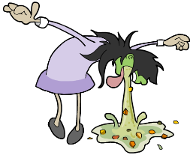 | They get into the body by eating raw food as well as poisonous drinks. Also, they can get into the body by not washing food properly before eating. | Typhoid, Amebiasis  Cholera
Through a break in your skin  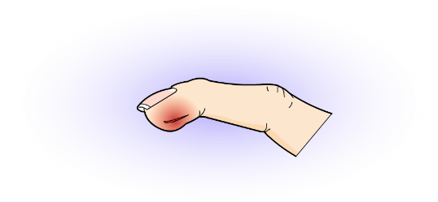 | Having direct exposure to blood or blood products as well as sharing of personal care items | Ringworms Histoplasmosis and Vaginal yeast infections.
Direct Contact  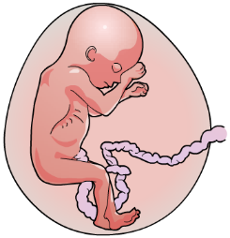 | Diseases are commonly transmitted through direct person-to-person contact. Transmission occurs when an infected person exchanges body fluids with someone else. | Syphilis, Gonorrhea, HIV/AIDS,
Indirect Contact  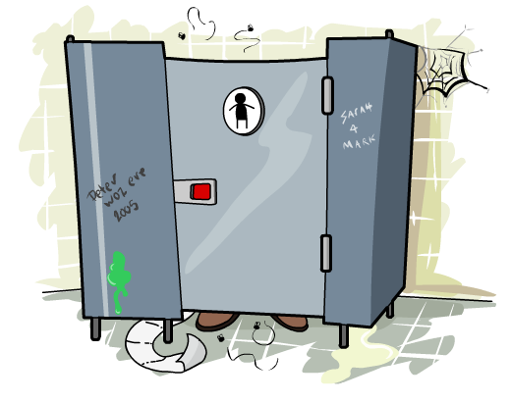 | They get through the air and other mechanisms. Infectious agents travel long distances and remain suspended in the air for an extended time. | Measles

2 Understand the nonspecific defenses of the body (2.1)

Task 2

Tetanus is caused by bacteria called Clostridium tetani. These bacteria can survive for a long time outside the body and are commonly found in soil and the manure of animals such as horses and cows. If they enter the body through a wound, the bacteria can quickly multiply, causing symptoms such as muscle stiffness and spasms. The bacteria can cause tetanus if they get into the body through cuts and scrapes
You are to produce a Poster to show the body's first line of defense, in other words how the body prevents the entry of Clostridium tetani bacteria and the second line of defense when bacteria have entered the body.
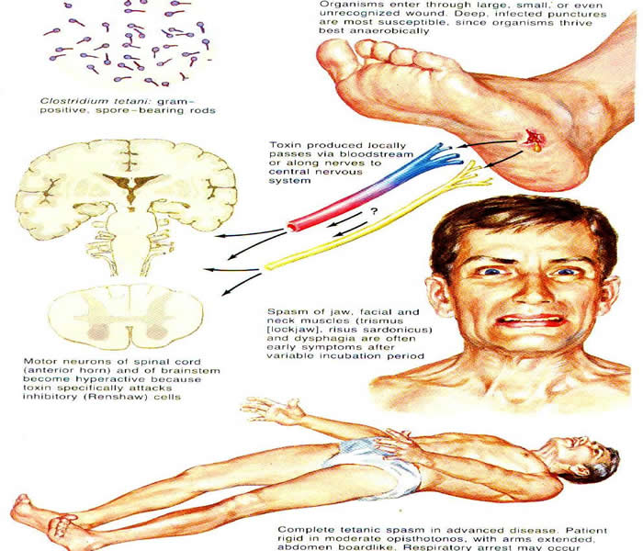
https://www.nigeriagalleria.com/Community-Health/Tetanus.html

- Understand the organisation of the immune system and the immune response (criteria 3.1 & 3.2)

Task 3
Produce two separate spider diagrams, one showing the organization of the immune system and the second immune response.

Organization of Immune response of the spider
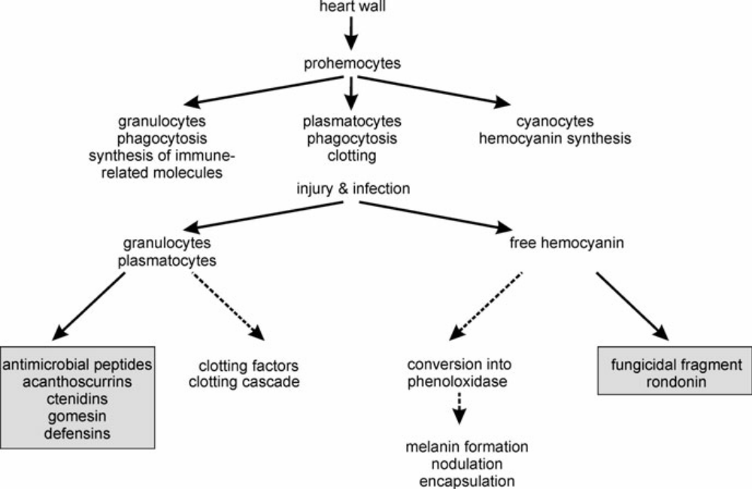
https://www.google.com/search?q=immune+response+of+the+spider&tbm=isch&source=iu&ictx=1&fir=RuyAvZcf03aDOM%253A%252CBWV7VHdWYqlqzM%252C_&vet=1&usg=AI4_-kQtVnD18QFA5sGiJM6enVmXqpru7A&sa=X&ved=2ahUKEwjz-Ie3nIjjAhVMyYUKHZLbCZEQ9QEwAHoECAIQAw#imgrc=RuyAvZcf03aDOM:

Immune response of the spider
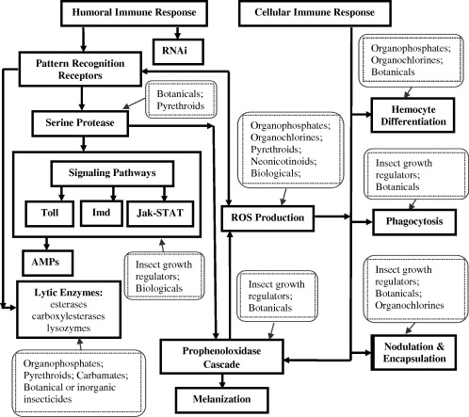
https://www.google.com/search?q=immune+response+of+the+spider&source=lnms&tbm=isch&sa=X&ved=0ahUKEwjz-Ie3nIjjAhVMyYUKHZLbCZEQ_AUIECgB&biw=1600&bih=789#imgrc=7Rv3RJzspZUiJM:

- Understand what is meant by acquired immunity (criteria 4.1 & 4.2)
Acquired immunity is the immunity acquired by infection, vaccination, or by the transfer of antibody and lymphocytes from an immune donor. Acquired resistance is in contrast to innate immunity.

Task 4a

What are antibodies, and how do they work?

They are protective protein produced by the immune system in response to the presence of antigen. As antibodies circulate the body, they attack and neutralize antigens that are identical to the one that triggered the immune response. Antibodies attack antigens by binding to them.

Task 4b.
Produce a large, clear flow diagram to describe how vaccinations help to stop pathogens, making us ill concerning information about the immune system.

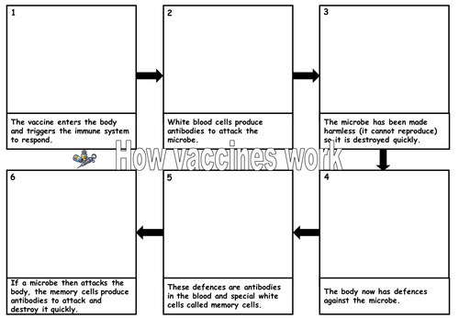
https://www.storyboardthat.com/storyboards/zahrasafi/how-does-a-vaccine-work-
5. Understand the role of antibiotics in treating infection criteria (4.1 & 4.2.)
Task 5a

What are antibiotics, and how do they work?
Antibiotics are the substance that inhibits the growth and replication of a bacterium by killing them outright. They are used to treat bacterial infections. Some are highly specialized and are only effective against certain bacteria. For instance, antibiotics like broad-spectrum antibiotics, attack a wide range of bacteria, including ones that are beneficial to the body.

.

Task 5b.

All patients should be given antibiotics instead of vaccines”. Do you support this statement? Give reasons to support your answer.

Yes. This is because currently, antibiotics are the most preferred category of drugs used in medicine to particularly in most complex surgeries across the world.

